Two bats species in Copenhagen / Europe!

Pipistrellus pygmaeus, for more info:

<https://www.eurobats.org/about_eurobats/protected_bat_species/pipistrellus_pygmaeus>

Nyctalus noctula, for more info:

<https://www.eurobats.org/node/96?mode=lightframe>

Problem:

Autoclassifyer misunnderstanding social sound from Pipistrellus pygmaeus (figure 1) as a Nyctalus noctula (figure 2).

And machine learning help part those to species?

Figure 1: Pipistrellus pygmaeus with echolocation on around 53 and with social much lower from 40 to 17 kHz.

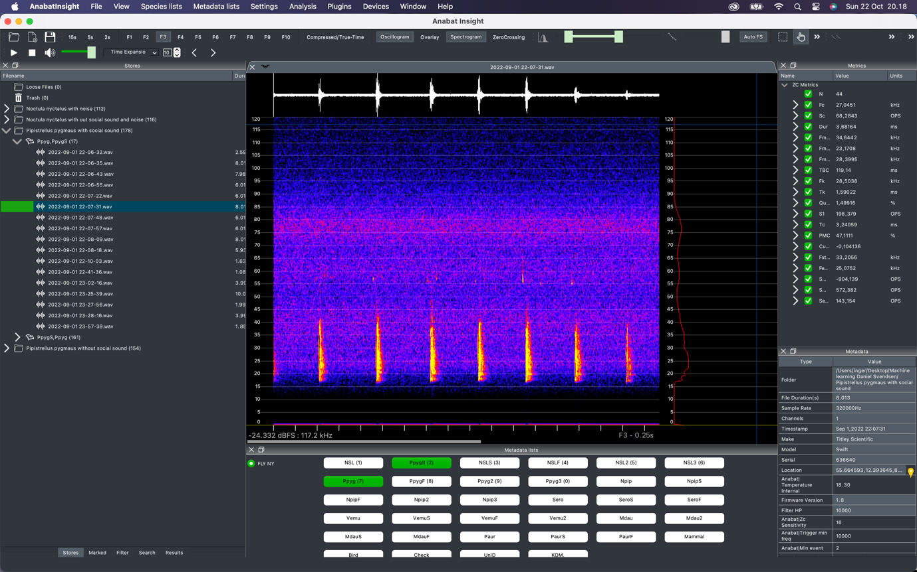

Figure 2: Echolocating Nyctalus noctula

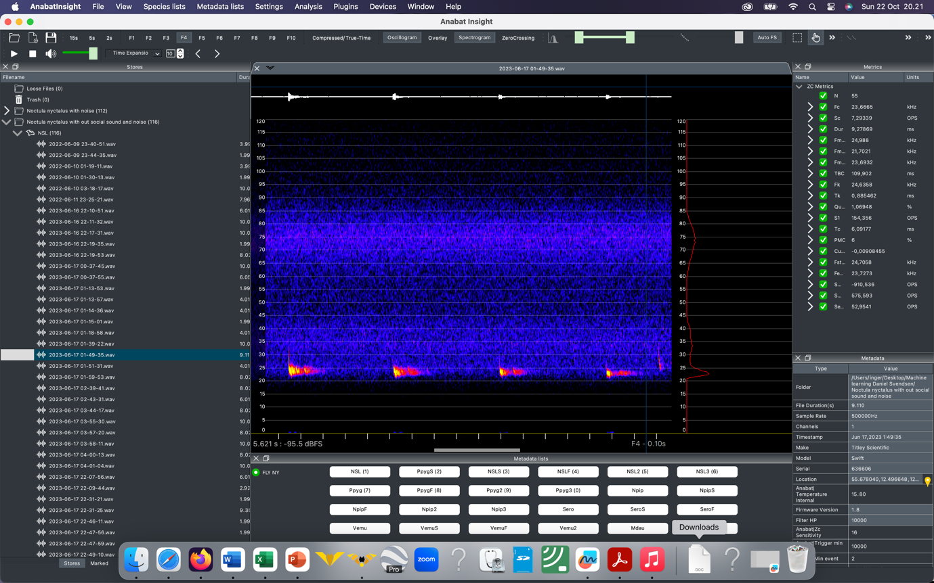

Human noise is often below 20 kHz

Echolocation is a tool used by bats (and some other animal for instance toothed whales). It is important to know it is a tool used for hunting and navigating (and also to some social communications), so if it is not working, the bats can change it. This means there are some variations in the echolocation.

Example:

Two Pipistrellus pygmaeus hunting together, both would, if they were alone use echolocation around 53 kHz, but when they are two, that is not smart, so one is hunting at around 49 kHz and they other one around 62 kHz. To not disturb each other!

Max energy, echolocation is always covering more frequencies!

The more frequencies covered, the more precise will the echo be, and the soundscape/landscape the bat is receiving.

A Nyctalus noctula flying in the open are in the need of long sight, and will have a lot of power/energy in one frequency!

Flying between branches close to a tree, a Pipistrellus needs to cover more frequencies to be able to not fly into the tree!

Be aware of feeding buzz’es. Bats have a search phase and if there is anything they will need to start echolocate faster, and at a feeding buzz, they could click up to 200 times per second!

See the below spectrogram!

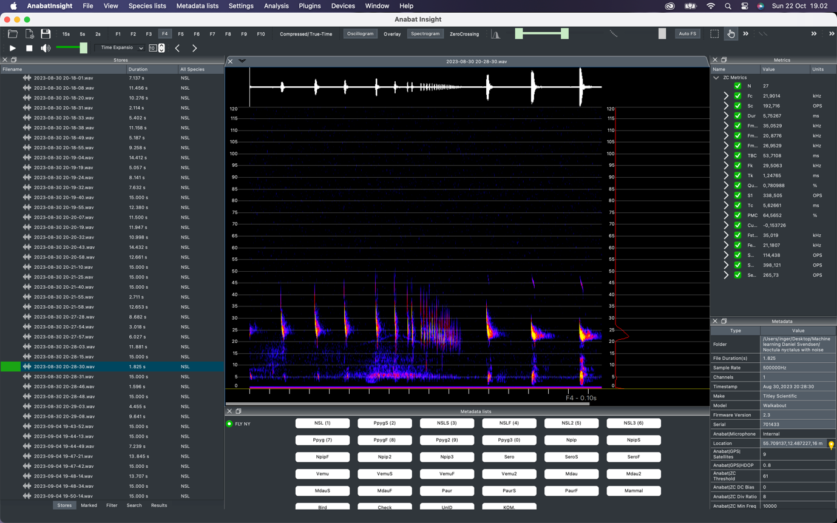

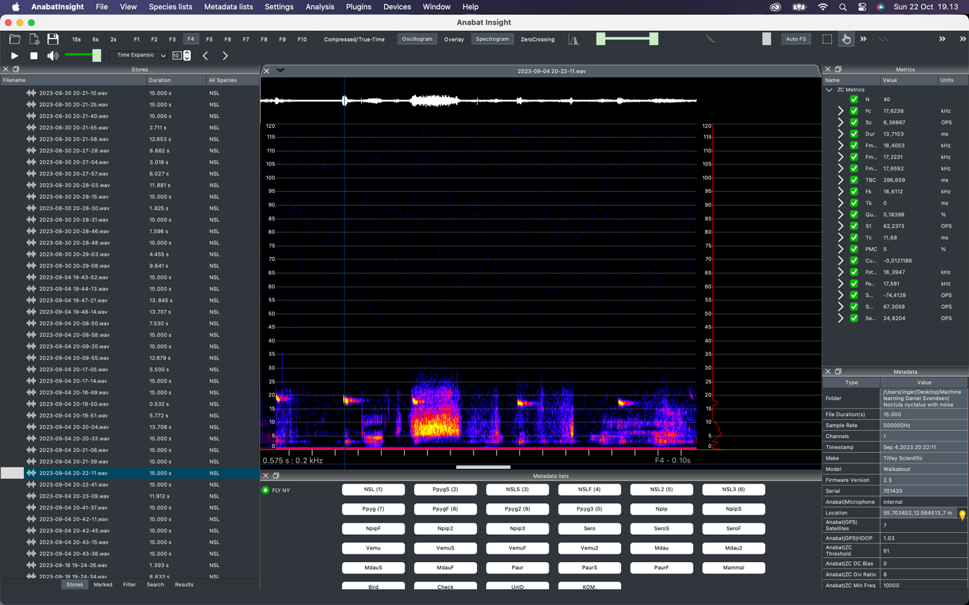



B=bat (Nyctalus noctula)

N=noise (Humans)

Det skriver jeg også, for så kan du måske klippe lidt forskelligt, men jeg har nu slettet de fleste filer som ikke starter med en tydelig flagermus!

Jeg er ikke helt sikker på, at du har brug for mappen med Pip pygmaeus uden sociale lyde!

God arbejdslyst og så kan jeg snakke med dine studerende, når de har valgt projekt ☺